
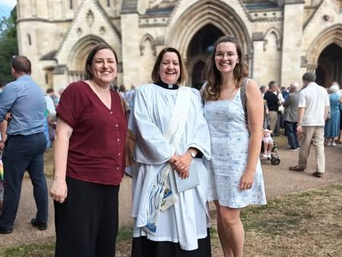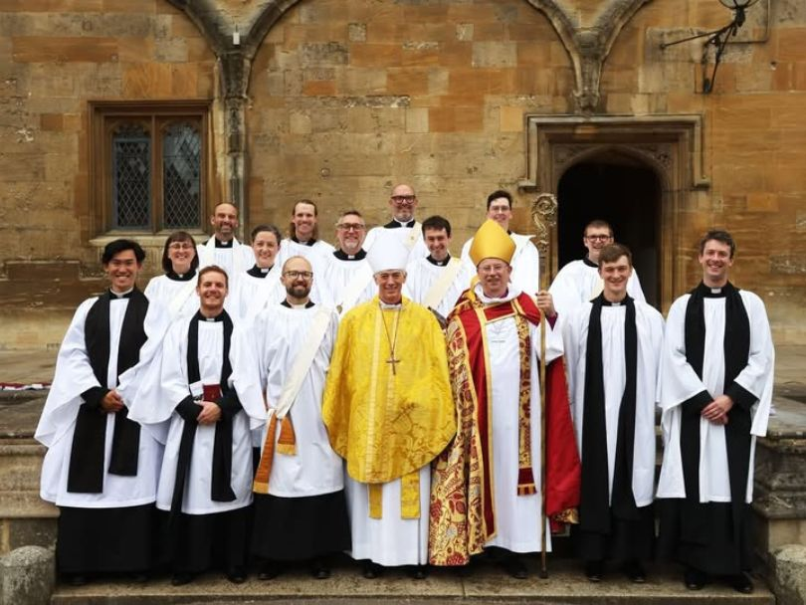
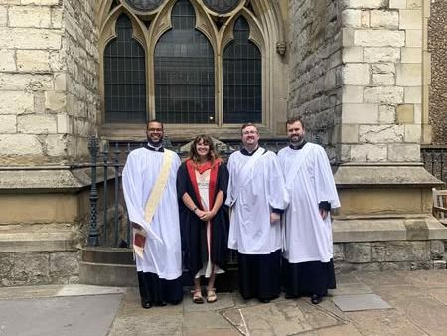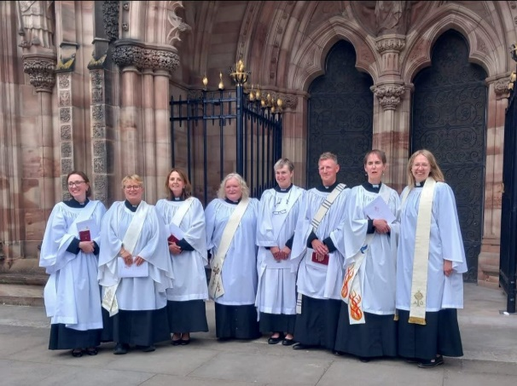
We pray for all our deacons and priests, and their parishes, as they are ordained and take the next step on their journey in God’s service.
Every one of this year's leavers has been matched to a curacy and our full Ember List for both deacons and priests can be found at rcc.ac.uk/news/ember-lists-2025.
_________________________________________________________

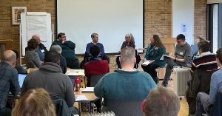
Incumbent Learning Programme
Cuddesdon is delighted to be one of the National Church's hubs hosting their Incumbent Development Programme equipping clergy to grow their mission and ministry with children, young people and families.
21 incumbents joined the programme at Cuddesdon in February. During the residential element, they learn from one another, join worship in a variety of traditions, receive expert teaching and discover practical resources and ideas. In addition, they also have discussion groups organised by local area, reflection tasks and a summer placement.
Candidates for this programme are nominated by their diocese but further information can be obtained from our Tutor for Children, Young People & Families, Dr Pete White at pete.white@rcc.ac.uk
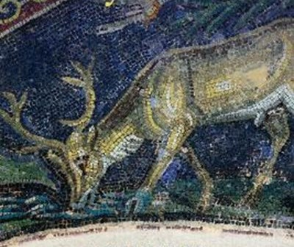
So Longeth My Soul: spiritual renewal, past and present
8 - 10 October 2025
Canon Dr Joanna Collicutt, author of So Longeth My Soul: A Reader in Christian Spirituality and Revd Dr Christopher Landau, Director of ReSource, will lead this 3-day retreat reflecting on texts from the history of Christian spirituality, bringing them into conversation with the challenges of fostering spiritual renewal in the contemporary church – particularly in ‘little, local, ordinary’ churches.
There will be time both for personal retreat and reflection, and also optional opportunities for discussion and conversation. We hope participants will be keen to share about, and learn from, one another’s contexts and experience.
rcc.ac.uk/short-courses-retreats/so-longeth-my-soul-spiritual-renewal-past-and-present
_________________________________________________________

Farewells and Welcomes
As we say fond farewells to our student leavers, we also say goodbye to our Tutor in Mission and Pastoral Studies, Dr Victoria Turner. Alongside her teaching this year, Victoria released a new book that she edited titled "Awake, emerging and connected - Meditations on Justice from a Missing Generation". We wish Victoria every success in her future.
Meanwhile, we have been very busy recruiting new staff. Following the recent announcement of Bishop Humphrey's retirement as Principal next December, we have held a successful recruitment campaign and a very exciting new appointment will be announced in due course.
We will also be able to announce shortly a replacement tutor to fill Victoria's role, and a new Business Manager to develop our already very successful programme of strategic partnerships, retreats and conference business.
_________________________________________________________

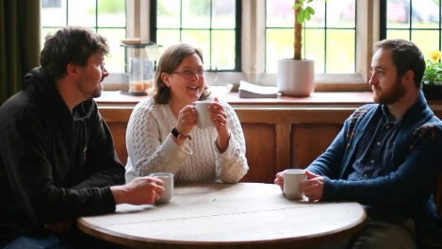
OPEN DAYS 2025-26
Saturday, 15 November 2025
Saturday, 24 January 2026
Saturday, 25 April 2026
For all questions about Admissions: admissions@rcc.ac.uk

RIPON COLLEGE CUDDESDON, OXFORD OX44 9EX
www.rcc.ac.uk 01865 874404

